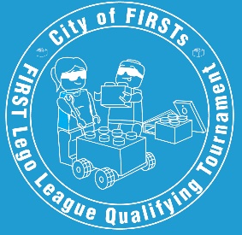

FLL City of Firsts
T-Shirt Order

Order FLL shirts for your team! Shirts are yellow and have the City of Firsts FLL Tournament logo on the front, this year’s game logo and event sponsors on the back. Complete the order form below and email it to jdewing@kokomo.k12.in.us by
Wednesday, Oct. 29 at noon. Bring payment with you the day of the event.

Prices: Child’s S-Adult XL - $13.00 Adult 2XL - $15.00 Adult 3X+ - $16.00

Team Name_______________________________________
Team Number ___________

Name  Please Print | Child |  |  | Adult Sizes
Name  Please Print | S | M | L | S | M | L | XL | 2XL | 3XL

You will receive your team’s t-shirts on the day of the event

