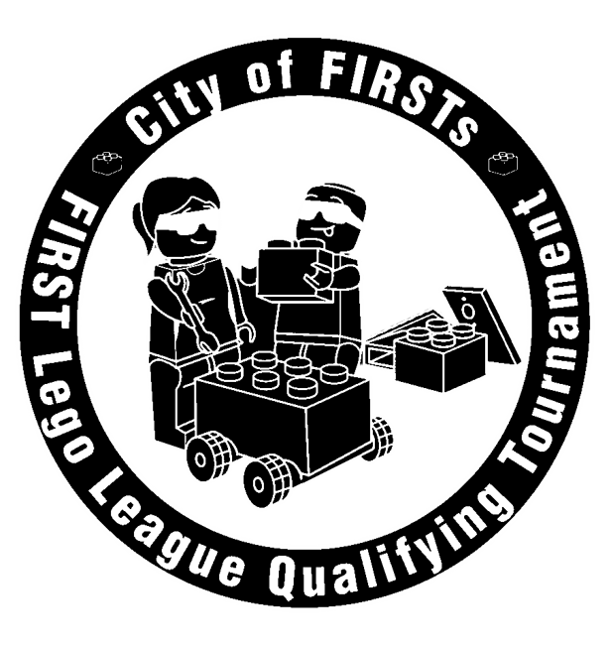
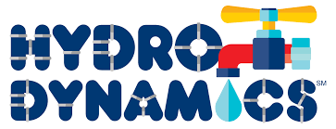
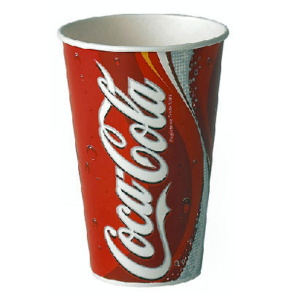
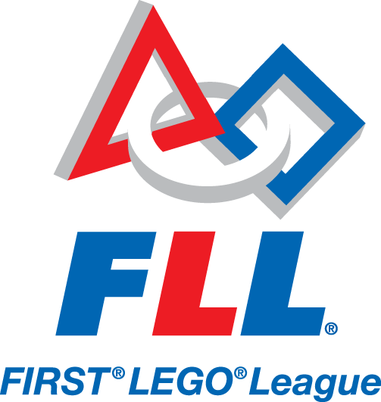
Lunch Pre-Order Items

Sub Sandwich Price
Roast Beef Turkey Ham $4.50

PIZZA (Sausage, Pepperoni, Cheese)
Whole Pizza $12.00
2 slices (same) $4.50

Beverages: Price
Coke*Sprite* Diet Coke (12 oz) $1.00
Water * $1.00

*Additional items available at the concession stand*
LUNCH DELIVERED TO YOUR TABLE!

If you would like to preorder lunch for the competition, just fill out this form and email it to jdewing@kokomo.k12.in.us by Friday, Nov. 7 at noon.
Lunch orders cannot be accepted after this date.

Bring your payment to the event on Nov. 15
Make checks payable to: TechnoKats

Choose from: Price
- sub sandwich (comes with cheese) $4.50

- 2 slices of pizza $4.50

- Drink: Coke, Diet Coke, Sprite, Water $1.00

- Whole large one-topping pizza
(Peperoni, Sausage or Cheese) $12.00

***************************************************

TEAM # ________ TEAM NAME: _______________________

COACH: _____________________________

Whole Large Pizzas: ____ Pepperoni ____ Sausage ____ Cheese

2 slices Pizza: ____ Pepperoni ____ Sausage ____ Cheese

Sub Sandwiches: ____Turkey ____Ham ____Roast Beef

Drinks: ____Coke ____Diet Coke ____Sprite ____Water

______ Ice Cream _____ Dairy Free Ice Cream Total $_________

